AI ASSISTED CODING (ASSIGNMENT-11.1)

Name: G. Siri Priya
Roll No: 2503A52718
Batch: 24

Q1
Task: Use AI to generate a Stack class with push, pop, peek, and is_empty
methods.
Sample Input Code:
class Stack:
pass
Prompt: generate a code on Stack class with push, pop, peek, and is_empty
methods.
Code:
class Stack:
def __init__(self):
self.items = []
def push(self, item):
self.items.append(item)
def pop(self):
if self.is_empty():
return None
return self.items.pop()
def peek(self):
if self.is_empty():
return None
return self.items[-1]

def is_empty(self):
return len(self.items) == 0
stack = Stack()
stack.push(10)
stack.push(20)
print("Top element:", stack.peek())
print("Popped element:", stack.pop())
print("Is stack empty?", stack.is_empty())
Output:
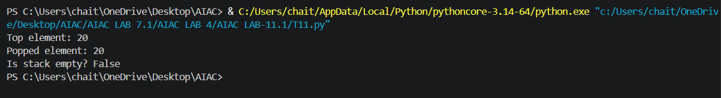

Q2
Task: Use AI to implement a Queue using Python lists.
Sample Input Code:
class Queue:
pass
Prompt: generate a code to implement a Queue using python list.
Code:
class Queue:
def __init__(self):
self._items = []
def enqueue(self, item):
"""Add an item to the rear of the queue."""
self._items.append(item)
def dequeue(self):

if self.is_empty():
return None
return self._items.pop(0)
def peek(self):
if self.is_empty():
return None
return self._items[0]
def is_empty(self):
return len(self._items) == 0
if __name__ == "__main__":
queue = Queue()
print("Is queue empty?", queue.is_empty())
queue.enqueue(10)
queue.enqueue(20)
queue.enqueue(30)
print("Queue after enqueueing 10, 20, 30:", queue._items)
print("Front item:", queue.peek())
print("Dequeued item:")
print(queue.dequeue())
print("Front item after dequeue:", queue.peek())
print("Is queue empty?", queue.is_empty())
output:
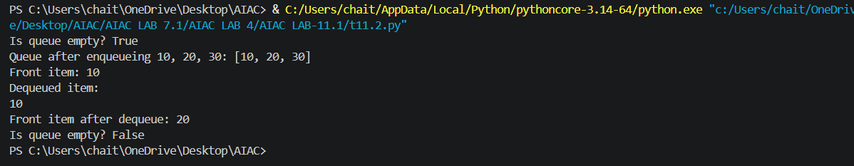
Q3
Task: Use AI to generate a Singly Linked List with insert and display
methods.
Sample Input Code:
class Node:
pass
class LinkedList:
pass
Prompt: generate a code on singly linked list with insert and display methods.
Code:
class Node:
def __init__(self, data):
self.data = data
self.next = None
class LinkedList:
def __init__(self):
self.head = None
def insert(self, data):
new_node = Node(data)
if self.head is None:
self.head = new_node
return
current = self.head
while current.next is not None:
current = current.next
current.next = new_node
def display(self):
current = self.head
values = []

while current is not None:
values.append(str(current.data))
current = current.next
print(" -> ".join(values) if values else "The list is empty.")
if __name__ == "__main__":
linked_list = LinkedList()
linked_list.insert(10)
linked_list.insert(20)
linked_list.insert(30)
print("Linked list:")
linked_list.display()
ouput:
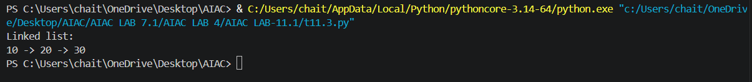
Q4
Task: Use AI to create a BST with insert and in-order traversal methods.
Sample Input Code:
class BST:
pass
Prompt: generate a code on BST with insert and in-order traversal methods.
Code:
class Node:
def __init__(self, data):
self.data = data
self.left = None
self.right = None
class BST:
def __init__(self):
self.root = None
def insert(self, data):
"""Insert a value into the tree."""
self.root = self._insert(self.root, data)
def _insert(self, node, data):
if node is None:
return Node(data)
if data < node.data:
node.left = self._insert(node.left, data)
elif data > node.data:
node.right = self._insert(node.right, data)
return node
def in_order(self):
values = []
self._in_order(self.root, values)
return values
def _in_order(self, node, values):
if node is not None:
self._in_order(node.left, values)
values.append(node.data)
self._in_order(node.right, values)
if __name__ == "__main__":
bst = BST()
for value in (50, 30, 70, 20, 40, 60, 80):
bst.insert(value)
print("In-order traversal:", bst.in_order())
output:
Q5
Task: Use AI to implement a priority queue using Python’s heapq
module.
Sample Input Code:
class PriorityQueue:
pass
Prompt: generate a code to implement a priority queue using Python’s heapq
module.
Code:
import heapq

class PriorityQueue:
def __init__(self):
self._items = []

def insert(self, item):
"""Add an item to the priority queue."""
heapq.heappush(self._items, item)

def remove(self):
"""Remove and return the item with the highest priority."""
return heapq.heappop(self._items)

def peek(self):
"""Return the highest-priority item without removing it."""
return self._items[0]

def is_empty(self):
return len(self._items) == 0

if __name__ == "__main__":
queue = PriorityQueue()
for item in (5, 1, 3, 2, 4):
queue.insert(item)

print("Priority order:", end=" ")
while not queue.is_empty():
print(queue.remove(), end=" ")
output:
Q6
Task:Use AI to implement a double-ended queue using
collections.deque.
Sample Input Code:
class DequeDS:
prompt: generate a code to implement a double-ended queue using
collections.deque.
code:
from collections import deque
class DoubleEndedQueue:
"""A double-ended queue (deque)."""

def __init__(self):
"""Create an empty deque."""
self._items = deque()

def add_front(self, item):
"""Add an item to the front of the deque."""
self._items.appendleft(item)

def add_rear(self, item):
"""Add an item to the rear of the deque."""
self._items.append(item)

def remove_front(self):
"""Remove and return the front item, or None if empty."""
if self.is_empty():
return None
return self._items.popleft()

def remove_rear(self):
"""Remove and return the rear item, or None if empty."""
if self.is_empty():
return None
return self._items.pop()

def is_empty(self):
"""Return True when the deque has no items."""
return len(self._items) == 0

if __name__ == "__main__":
queue = DoubleEndedQueue()

queue.add_rear(10)
queue.add_rear(20)
queue.add_front(5)
print("Deque after adding 10, 20 at the rear and 5 at the front:", queue._items)
print("Removed from front:", queue.remove_front())
print("Removed from rear:", queue.remove_rear())
print("Deque after removals:", queue._items)
print("Is deque empty?", queue.is_empty())
output:
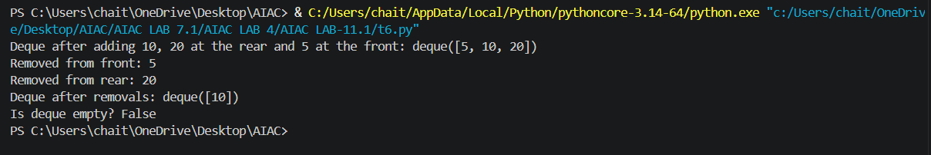

Task Description #7 Real-Time Application Challenge – Choose the
Right Data Structure
Scenario:
Your college wants to develop a Campus Resource Management System
that handles:
1. Student Attendance Tracking – Daily log of students
entering/exiting the campus.
2. Event Registration System – Manage participants in events with
quick search and removal.
3. Library Book Borrowing – Keep track of available books and their
due dates.

4. Bus Scheduling System – Maintain bus routes and stop
connections.
5. Cafeteria Order Queue – Serve students in the order they arrive.
Student Task:
• For each feature, select the most appropriate data structure from
the list below:
o Stack
o Queue
o Priority Queue
o Linked List
o Binary Search Tree (BST)
o Graph
o Hash Table
o Deque
• Justify your choice in 2–3 sentences per feature.
• Implement one selected feature as a working Python program with
AI-assisted code generation.
Expected Output:
• A table mapping feature → chosen data structure → justification.
• A functional Python program implementing the chosen feature
with comments and docstrings.
Prompt:
Build a beginner-friendly Python project for Task #7: Campus Resource Management System. Implement the Cafeteria Order Queue using a Queue data structure (FIFO — First In, First Out). Include options to add a student's order, serve the next order, display pending orders, and exit the program. Use functions, a Python deque, comments, and docstrings. Handle empty queues and invalid inputs properly. Write clean, working Python code in a single file named cafeteria_queue.py that I can run directly in VS Code.

CODE:
"""A simple FIFO queue for managing student cafeteria orders."""

from collections import deque

def add_order(orders: deque[tuple[str, str]]) -> None:
"""Collect a student's order and add it to the end of the queue."""
student_name = input("Enter the student's name: ").strip()
if not student_name:
print("Student name cannot be empty. Order was not added.")
return

food_order = input("Enter the food order: ").strip()
if not food_order:
print("Food order cannot be empty. Order was not added.")
return

# append() adds each new order behind the orders already waiting.
orders.append((student_name, food_order))
print(f"Order added for {student_name}: {food_order}")

def serve_next_order(orders: deque[tuple[str, str]]) -> None:
"""Serve and remove the oldest order, if one is waiting."""
if not orders:
print("There are no pending orders to serve.")
return

# popleft() serves the first order added, preserving FIFO order.
student_name, food_order = orders.popleft()
print(f"Serving {student_name}: {food_order}")

def display_pending_orders(orders: deque[tuple[str, str]]) -> None:
"""Display all orders in the order they will be served."""
if not orders:
print("There are no pending orders.")
return

print("\nPending orders (first in, first out):")
for number, (student_name, food_order) in enumerate(orders, start=1):
print(f"{number}. {student_name}: {food_order}")

def main() -> None:
"""Run the cafeteria order queue menu until the user exits."""
orders: deque[tuple[str, str]] = deque()

while True:
print("\n=== Cafeteria Order Queue ===")
print("1. Add a student's order")
print("2. Serve the next order")
print("3. Display pending orders")
print("4. Exit")

choice = input("Choose an option (1-4): ").strip()

if choice == "1":
add_order(orders)
elif choice == "2":
serve_next_order(orders)
elif choice == "3":
display_pending_orders(orders)
elif choice == "4":
print("Exiting the cafeteria order queue. Goodbye!")
break
else:
print("Invalid choice. Please enter a number from 1 to 4.")

if __name__ == "__main__":
main()
output:

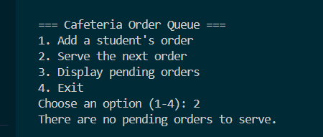

Task Description #8: Smart E-Commerce Platform – Data Structure
Challenge
An e-commerce company wants to build a Smart Online Shopping System
with:
1. Shopping Cart Management – Add and remove products
dynamically.
2. Order Processing System – Orders processed in the order they are
placed.
3. Top-Selling Products Tracker – Products ranked by sales count.

4. Product Search Engine – Fast lookup of products using product ID.
5. Delivery Route Planning – Connect warehouses and delivery
locations.
Student Task:
• For each feature, select the most appropriate data structure from
the list below:
o Stack
o Queue
o Priority Queue
o Linked List
o Binary Search Tree (BST)
o Deque
• Justify your choice in 2–3 sentences per feature.
• Implement one selected feature as a working Python program with
AI-assisted code generation.
Expected Output:
• A table mapping feature → chosen data structure → justification.
• A functional Python program implementing the chosen feature
with comments and docstrings.
Promt:
Build a beginner-friendly Python project for Task #8: Smart E-Commerce Platform. Implement the Shopping Cart Management feature using a Linked List data structure. Include options to add products, remove products, display all cart items, and exit the program. Use functions, classes, comments, and docstrings. Handle empty carts, duplicate products, and invalid inputs properly. Also include a short table explaining the most suitable data structure for all five features: Shopping Cart (Linked List), Order Processing (Queue), Top-Selling Products (Priority Queue), Product Search by ID (BST), and Delivery Route Planning (Graph). Give a 2–3 sentence justification for each choice. Write clean, working Python code in a single file named ecommerce_cart.py that runs directly in VS Code.

Code:

class CartNode:
"""A linked-list node containing one product name."""

def __init__(self, product_name: str) -> None:
self.product_name = product_name
self.next: CartNode | None = None

class ShoppingCart:
"""Store unique product names in insertion order using linked nodes."""

def __init__(self) -> None:
self.head: CartNode | None = None
self.tail: CartNode | None = None

def contains(self, product_name: str) -> bool:
"""Return whether the cart already contains this product name."""
current = self.head
while current is not None:
if current.product_name.casefold() == product_name.casefold():
return True
current = current.next
return False

def add_product(self, product_name: str) -> bool:
"""Append a product unless a name-matching product is already present."""
if self.contains(product_name):
return False

new_node = CartNode(product_name)
if self.head is None:
self.head = new_node
else:
# Link the new node after the current last node.
self.tail.next = new_node
self.tail = new_nodedesert
return True

def remove_product(self, product_name: str) -> bool:
"""Remove a product by name, ignoring letter case."""
previous: CartNode | None = None
current = self.head

while current is not None:
if current.product_name.casefold() == product_name.casefold():
if previous is None:
self.head = current.next
else:
previous.next = current.next

if current is self.tail:
self.tail = previous
return True

previous = current
current = current.next

return False

def display_products(self) -> None:
"""Print the products in the order they were added."""
if self.head is None:
print("Your shopping cart is empty.")
return

print("\nProducts in your shopping cart:")
current = self.head
number = 1
while current is not None:
print(f"{number}. {current.product_name}")
current = current.next
number += 1

def add_product(cart: ShoppingCart) -> None:
"""Ask for a product name and add it to the cart."""
product_name = input("Enter the product name to add: ").strip()
if not product_name:
print("Product name cannot be empty.")
elif cart.add_product(product_name):
print(f"Added '{product_name}' to your cart.")
else:
print(f"'{product_name}' is already in your cart. Duplicate not added.")

def remove_product(cart: ShoppingCart) -> None:
"""Ask for a product name and remove it from the cart."""
product_name = input("Enter the product name to remove: ").strip()
if not product_name:
print("Product name cannot be empty.")
elif cart.remove_product(product_name):
print(f"Removed '{product_name}' from your cart.")
else:
print(f"'{product_name}' was not found in your cart.")

def main() -> None:
"""Run the shopping cart menu until the user chooses to exit."""
cart = ShoppingCart()

while True:
print("\n=== Smart E-Commerce Shopping Cart ===")
print("1. Add a product")
print("2. Remove a product")
print("3. Display all cart items")
print("4. Exit")

choice = input("Choose an option (1-4): ").strip()

if choice == "1":
add_product(cart)
elif choice == "2":
remove_product(cart)
elif choice == "3":
cart.display_products()
elif choice == "4":
print("Exiting the shopping cart. Goodbye!")
break
else:
print("Invalid choice. Please enter a number from 1 to 4.")

if __name__ == "__main__":
main()

output:

